EXPERIMENT 1

ROLL NO: 240701229 NAME: Karthavya S

USER INTERFACE AND DESIGN
Comparison Between Two Figma Mobile Interface

BAD UI
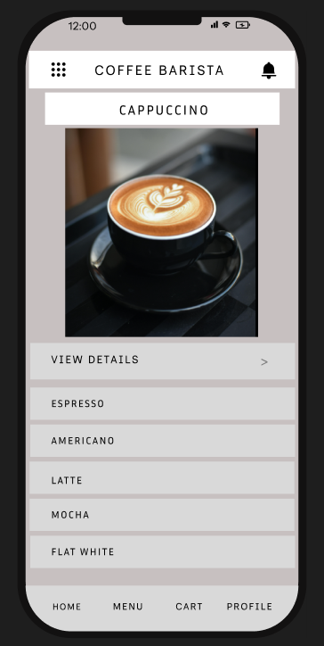

Prototype Link: https://www.figma.com/design/MELp9hxNp1Rfwvs5ax1Rak/good-ui-vs-bad-ui?node-id=15-261&t=UD4Xl1h94TMzWb1u-0

GOOD UI
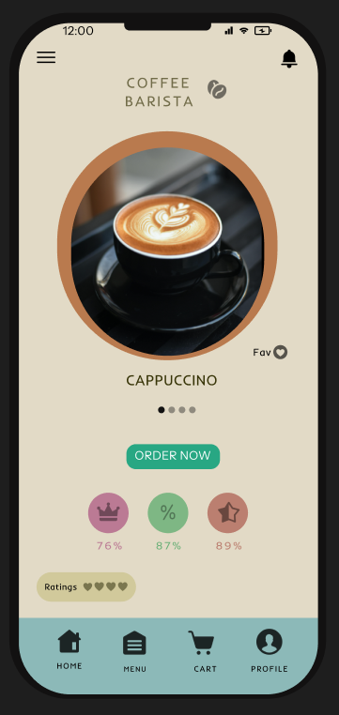

Prototype Link:
https://www.figma.com/design/MELp9hxNp1Rfwvs5ax1Rak/good-ui-vs-bad-ui?node-id=15-151&t=UD4Xl1h94TMzWb1u-0

Bad User Interface:
- Design Style:
Minimal, clean, modern. Soft, neutral color palette. Simple, Inder typography. High-quality imagery. Card-based layout.
- Content:
Header (Coffee barista), Cappuccino title, Cappuccino image, View details button, Menu list (Espresso, Americano, etc.), Footer (Home, Menu, etc.).
- Navigation:
Top header menu, View details button, Bottom tab bar (Home, Menu, Cart, Profile), Menu list.
- Purpose:
Mobile coffee shop app for ordering and browsing. Highlights Cappuccino, allows viewing details or selecting other drinks. User is likely exploring the menu.

Good User Interface :
- Design Style:
Warm, inviting, modern. Earthy color palette (beige, brown, teal). Playful, friendly typography. High-quality, rounded imagery. Creative layout.
- Content:
Header (Coffee barista), Cappuccino title, Cappuccino image, Fav button, Pagination dots, Order now button, Ratings (76%, 87%, 89%), Heart ratings, Footer (Home, Menu, etc.).
- Navigation:
Top header menu, Order now button, Bottom tab bar (Home, Menu, Cart, Profile), Pagination dots.
- Purpose:
Mobile coffee shop app for ordering/browsing. Highlights Cappuccino, allows ordering or favoring. User is likely browsing the menu.

Key Differences :
- The first interface prioritizes a clean, minimalist structure with a neutral color palette, whereas the second uses a warm, inviting, and playful aesthetic with earthy tones.
- Information in the first image is presented in a top-down list hierarchy, while the second image uses a hero-centric approach with a large central focus on the product.
- The main call-to-action in the first design is "View Details," indicating a multi-step flow, compared to the direct "Order Now" button in the second design.
- The second interface includes interactive features like a "Fav" button, pagination dots for a carousel, and rating badges that are missing from the first interface.
- Visually, the first image uses a square photo and uniform font on a grey background, while the second uses a circular photo with a border and stylized fonts on a beige and teal background.

